Slide one:

Topic and Group members

Slide two - Fuzzy Logic (FL):

The concept of Fuzzy Logic (FL) was conceived by Lotfi Zadeh, a professor at the University of California at Berkley

FL is a form of probabilistic logic which deals with approximate results.

It incorporates a simple, rule-based IF X AND Y THEN Z approach to solving a control problem.



Slide 3:

FL lends itself to implementation in systems ranging from simple, small,embedded micro-controllers

to large, networked, multi-channel PC or control systems.

1.Many electronic control systems in the automotive industry such as

automatic transmissions, engine control and Anti-lock Brake Systems (ABS) realize superior characteristics through the set of fuzzy logic

based control rather than traditional control algorithms.

2.FL is also used in washing machines, where the length of wash is determined by the volume of clothes and dirt.

There was no suitable alternative to personal trial and error.

Slide 4 – Temperature Control System :

This controller can be applied to any system which we need to maintain at a particular temperature!

The Fuzzy temperature controller will make use of two parameters :

1. Constant temperature as per the requirement(Cmd).

2. Instantaneous temperature of the system(Temp).

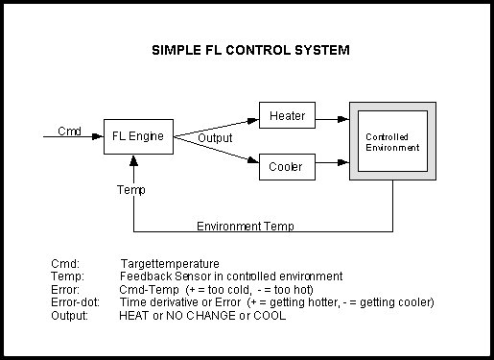

Slide 5 – Fuzzy Parameters and Rule Matrix

In our implementation, fuzzy parameters of error (command-feedback) and error-dot (rate-of-change-of-error)are modified by the

adjectives "negative", "zero", and "positive".

For a meaningful interpretation of the rule matrix, we use the following notations :

"N" = "negative" error or error-dot input level

"Z" = "zero" error or error-dot input level

"P" = "positive" error or error-dot input level

"H" = "Heat" output response

"NC" = "No Change" to current output

"C" = "Cool" output response

Slide 6 -

A rule matrix is a 3x3 matrix.

The columns represent "negative", "zero", and "positive" "error" inputs from left to right.

The rows represent "negative", "zero", and "positive" "error-dot" input from top to bottom.

image of matrix

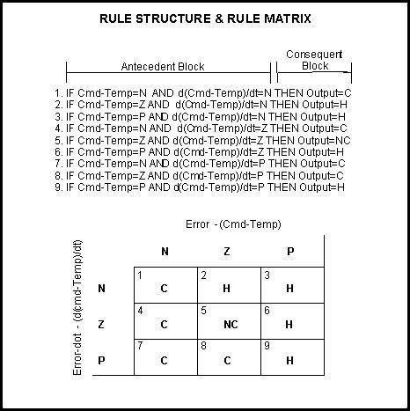

Slide 7 – Input Degree of Membership

"error" = -1.0: "negative" = 0.5, "zero" = 0.5, "positive" = 0.0

"error-dot" = +2.5: "negative" = 0.0, "zero" = 0.5, "positive" = 0.5

1. If (e < 0) AND (er < 0) then Cool 0.50 & 0.00 = 0.00

2. If (e = 0) AND (er < 0) then Heat 0.50 & 0.00 = 0.00

3. If (e > 0) AND (er < 0) then Heat 0.00 & 0.00 = 0.00

4. If (e < 0) AND (er = 0) then Cool 0.50 & 0.50 = 0.50

5. If (e = 0) AND (er = 0) then No_Chng 0.50 & 0.50 = 0.50

6. If (e > 0) AND (er = 0) then Heat 0.00 & 0.50 = 0.00

7. If (e < 0) AND (er > 0) then Cool 0.50 & 0.50 = 0.50

8. If (e = 0) AND (er > 0) then Cool 0.50 & 0.50 = 0.50

9. If (e > 0) AND (er > 0) then Heat 0.00 & 0.50 = 0.00

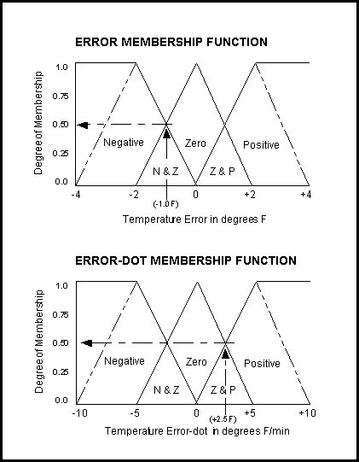

Slide 8 and 9 – Defuzzification

From the last slide we see that rules 4, 5, 7, and 8 each fired at 50% or 0.5 while rules 1, 2, 3, 6, and 9 do not fire at all

The logical products for each rule must be combined before being passed on to the defuzzification process for crisp output generation.

We use The ROOT-SUM-SQUARE (RSS) method which combines the effects of all applicable rules, scales the functions at their respective magnitudes, and computes the "fuzzy" centroid of the composite area.

"negative" = (R1^2 + R4^2 + R7^2 + R8^2) (Cooling) = (0.00^2 + 0.50^2 + 0.50^2 + 0.50^2)^.5 = 0.866

"zero" = (R5^2)^.5 = (0.50^2)^.5 (No Change) = 0.500

"positive" = (R2^2 + R3^2 + R6^2 + R9^2) (Heating) = (0.00^2 + 0.00^2 + 0.00^2 + 0.00^2)^.5 = 0.000

(neg_center * neg_strength + zero_center * zero_strength + pos_center * pos_strength) = OUTPUT

(neg_strength + zero_strength + pos_strength)

(-100 * 0.866 + 0 * 0.500 + 100 * 0.000) = -63.4% (cooling)

(0.866 + 0.500 + 0.000)

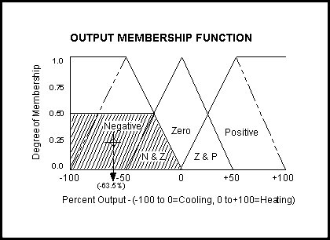

Slide 10 – Implementation

Using Fuzzy Logic we have implemented a system which shows whether the temperature of the surrounding is more or less than the temperature which has been predefined.

For this we have used Arduino microcontroller board, LM35 temperature sensor and two LEDs.

Slide 11:

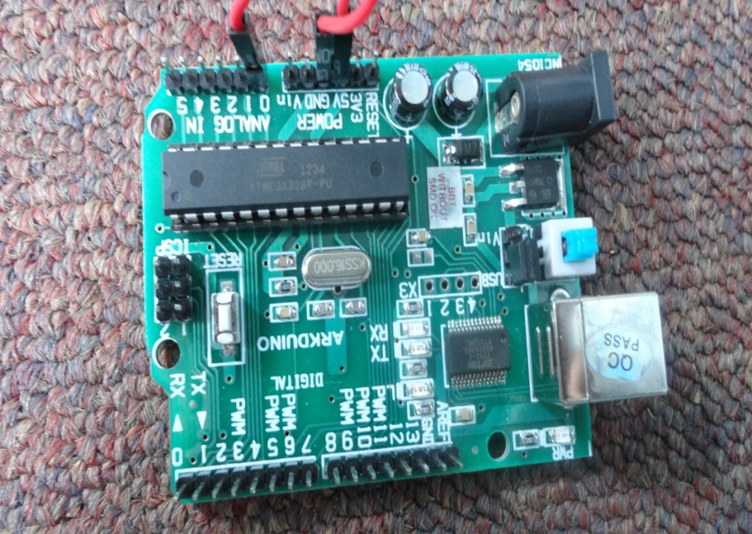

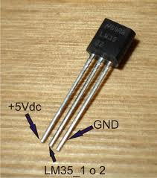

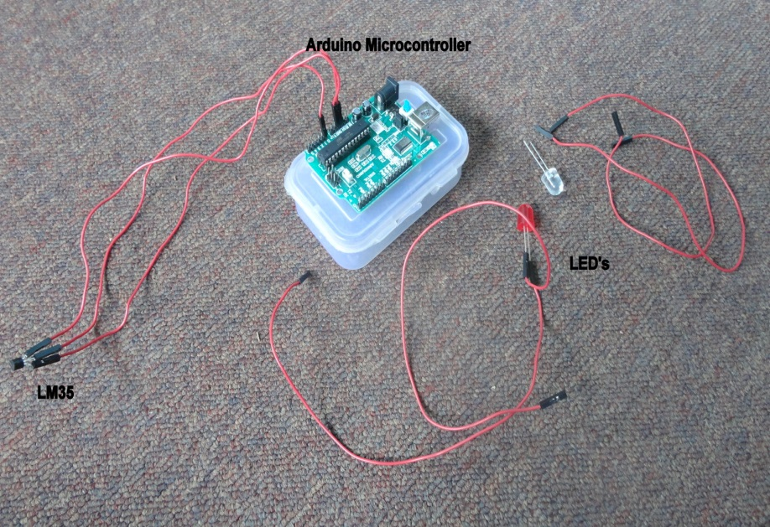

Slide 12:

The fuzzy variables which we have used are:

1. Temperature read from the sensor (temp)
2. Temperature Difference(diff=temp-threshold)

Accordingly the rule matrix and the input membership function will change.

Slide 13:

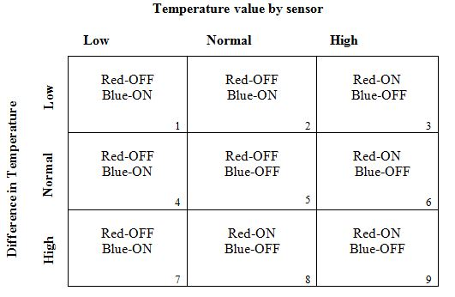

Graph-Missing

Slide 14:

COOL

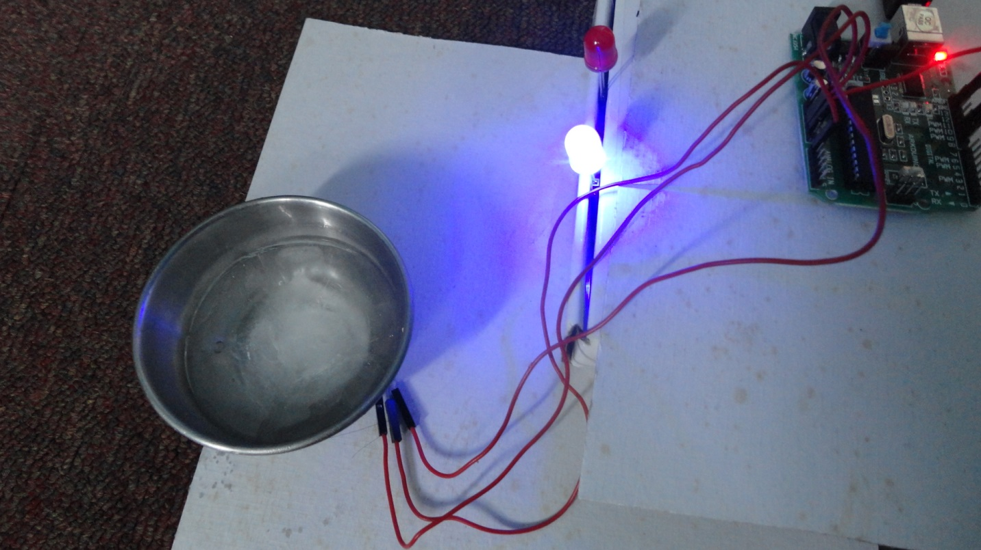

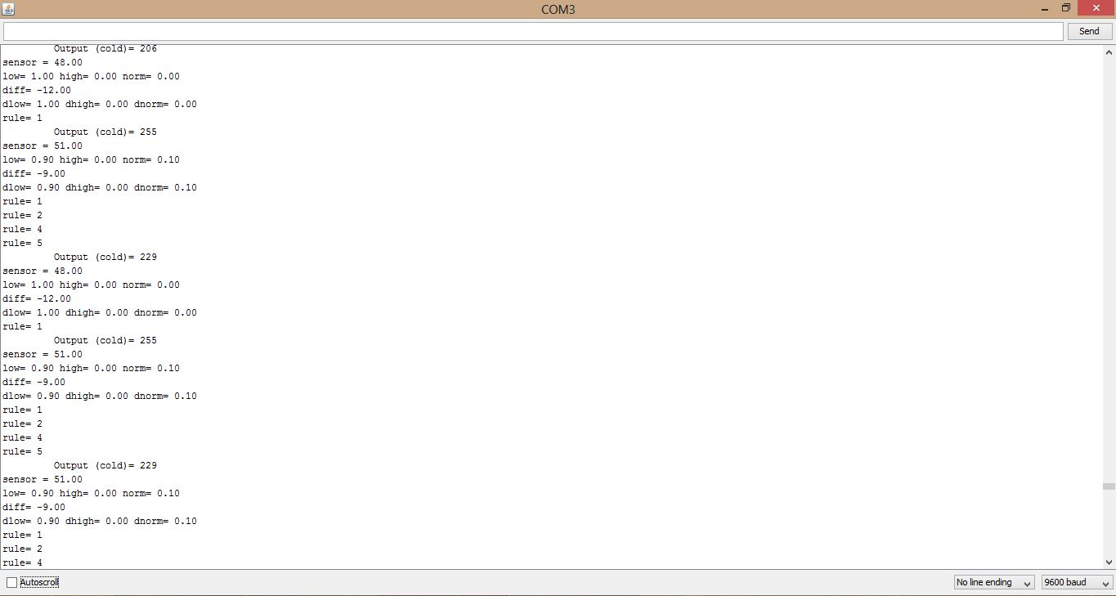

Slide 15:

HOT

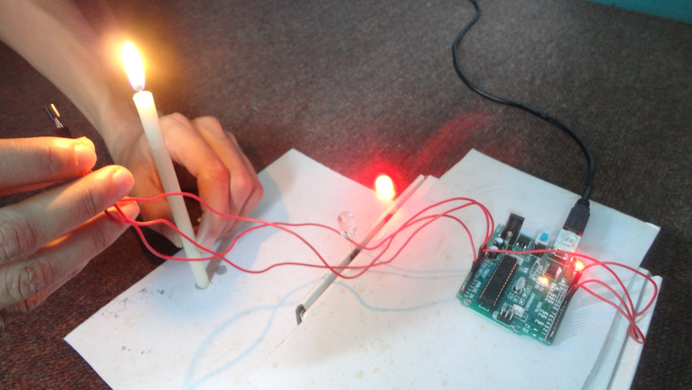

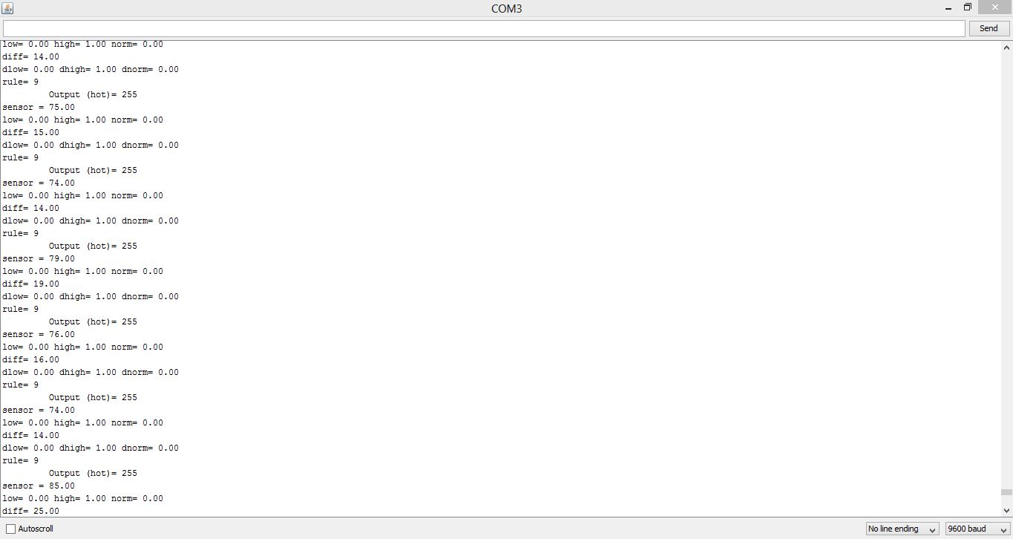

Slide 16:

Applications:

1.In air conditioners, dehumidification and temperature decrease goes hand in hand. However, the complex interactions between user preferences, room temperature and humidity level are very difficult to achieve mathematically.

2.In industries, where machines have to be maintained at a fixed temperature.

3. **A FUZZY LOGIC TEMPERATURE CONTROLLER can be used FOR PRETERM**

**NEONATE INCUBATOR**